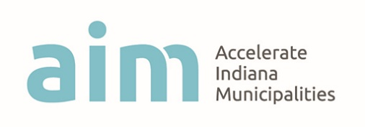
Aim Youth Councils Network
Aim, the advocacy group for Indiana’s cities and towns, is seeking interested applicants to serve on the 2018-19 Steering Committee to guide the Aim Youth Councils Network. The commitment will include: two (2) in-person meetings at Aim offices in Indianapolis, during the summer and fall, and potential conference calls leading up to the network’s events. An independent panel will select the Steering Committee’s membership. High school students with experience on a local youth council are encouraged to apply. APPLICATION DEADLINE: MARCH 31, 2018. Please send completed applications to Chelsea Schneider, Aim Municipal Innovations Specialist, at cschneider@aimindiana.org.

NAME:
APPLYING FOR THIS POSITION (president, regional director-north/central/south, treasurer, secretary, events coordinator):
HIGH SCHOOL AND 2018-19 GRADE LEVEL:
LOCAL COUNCIL:
YEARS OF SERVICE ON LOCAL COUNCIL AND POSITIONS HELD:

Please detail your leadership experience.

What strengths would you bring to the steering committee?

How can the Aim Youth Councils Network best serve local councils?

Why did you choose to become a member of your local council?

REFERENCE
Name:
Relationship to applicant:
Contact:

